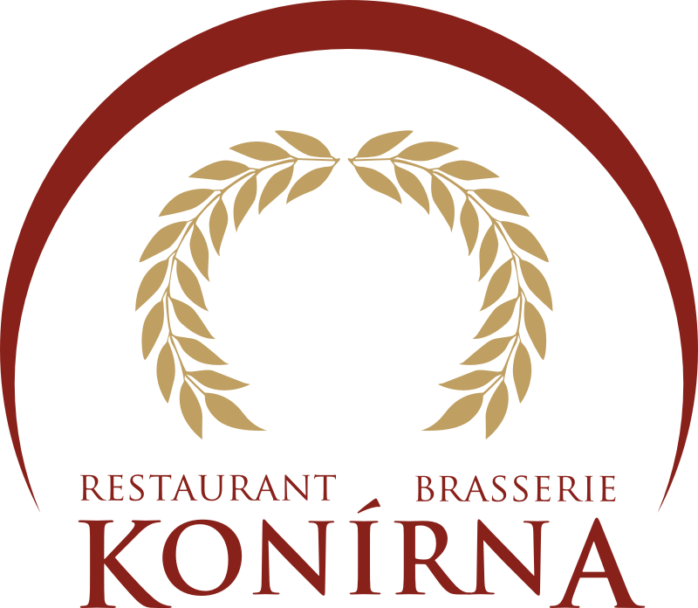
Konírna Restaurant-Brasserie
Buffet refreshment offer for 2012

+ Beverages – our beverage offer is found at the end of the food offer

We provide the following spaces for your use

Brasserie – seating capacity of 60
Restaurant – seating capacity of 60
Lounge – seating capacity of 20
Medieval wine cellar – seating capacity of 60
Medieval wine cellar – seating capacity of 2-24
Summer terrace – seating capacity of 80

Please don’t hesitate to contact us as we will also be pleased to prepare these refreshments for your catering needs, including delivery to the venue of your choice.

Traditional Czech cuisine

Cold dishes
Wild game pate with cranberry jelly
Crackling spread
Mixed salads (dressings: balsamic vinaigrette, garlic with sour cream), Caesar salad with roasted chicken, vegetable salad with onions and cheese
Prague ham with horseradish and pickled gherkins
Mini chicken schnitzels with lemon and pickled gherkins
Czech cheese platter (selection of soft and hard cheeses), served with grapes

Soup
Oxtail soup with noodles, vegetables and liver dumplings
Or
Homemade goulash with Hungarian paprika

Main dishes
Crisp roasted duck with red cabbage and apples, sauerkraut, potato dumplings with onions, bread dumplings
Classic sirloin beef in cream sauce with Carlsbad dumpling
Poached salmon trout with vegetables and herb sauce

Desserts
Apple strudel with mint, poppy crumbles cake
Classic Czech pastry tray

Bread – white baguette, freshly warmed caraway seed bread

CZK 590

-1-

Pork feast

Cold dishes
Cold meat platter – smoked bacon, Prague ham and smoked pork neck, served with pickled vegetables
Light head cheese with vinegar and onion, crackling spread
Pickled sausages with onion and spices
Green salads (dressings: dark balsamic vinaigrette and honey, yogurt with herbs)
Vegetable salad with olive oil and olives
Cold sausage with apple horseradish, mustard and pickled gherkin

Czech cheese platter (selection of soft and hard cheeses), served with grapes

Soup
Moravian sauerkraut soup with sour cream
or
Classic blood soup with barley and marjoram

Main dishes
Baked sausages, sauerkraut with apples, potatoes with chives
Spicy pork goulash with garlic and Hungarian paprika, boiled bread dumplings
Pike-perch in garlic, potatoes with chives and herb sauce

Desserts
Moravian cake with plum jams and crumbles
Cherry cake with chocolate; strawberry, apricot and peach mini-desserts

Bread – white baguette, fresh-baked caraway seed bread

CZK 590

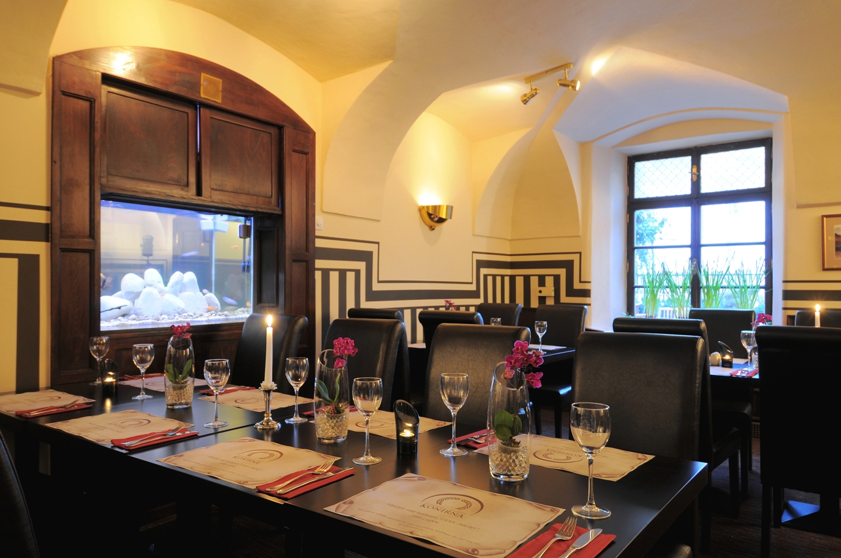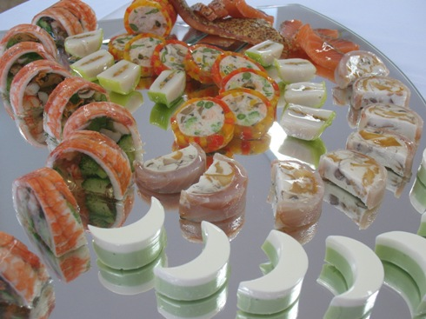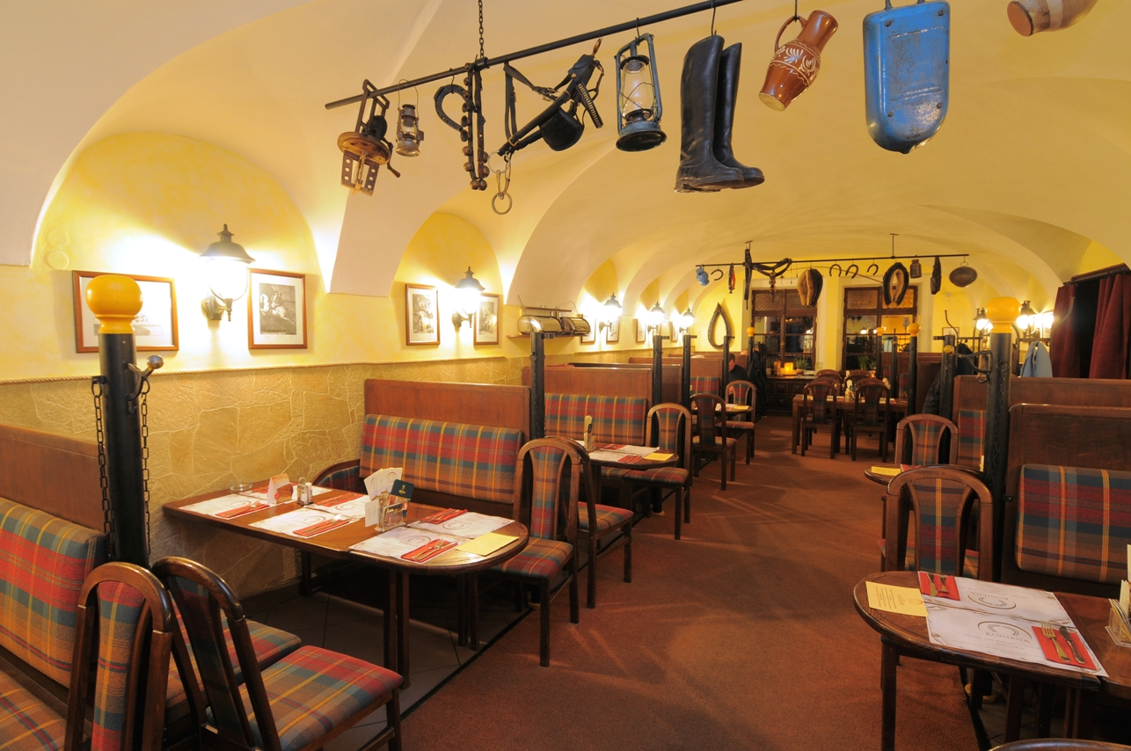

-2-

Medieval buffet

Cold dishes
Cold smoked meat platter – pork neck, chicken breast, Prague ham, Hungarian salami, pickled vegetables
Spicy marinated Hermelín cheese, pickled sausage
Vegetable salad with dressing, onions and cheese
Crackling spread with fried onions
Wild game pate with walnuts

Czech cheese platter (selection of soft and hard cheeses), served with grapes

Soup
Tripe soup
or
Homemade goulash soup with Hungarian paprika

Main dishes
Baked lean pork ribs in spicy marinade, potatoes sautéed with cabbage and bacon.
¼ roasted chicken with onions and herbs, hearty juice and warm bread
Pike-perch with herbs and garlic, smooth potato puree

Desserts
Apple strudel with raisins
Walnut bundt cake
Chocolate cake
Selection of mini-desserts

Bread – white baguette, freshly warmed caraway seed bread

CZK 590

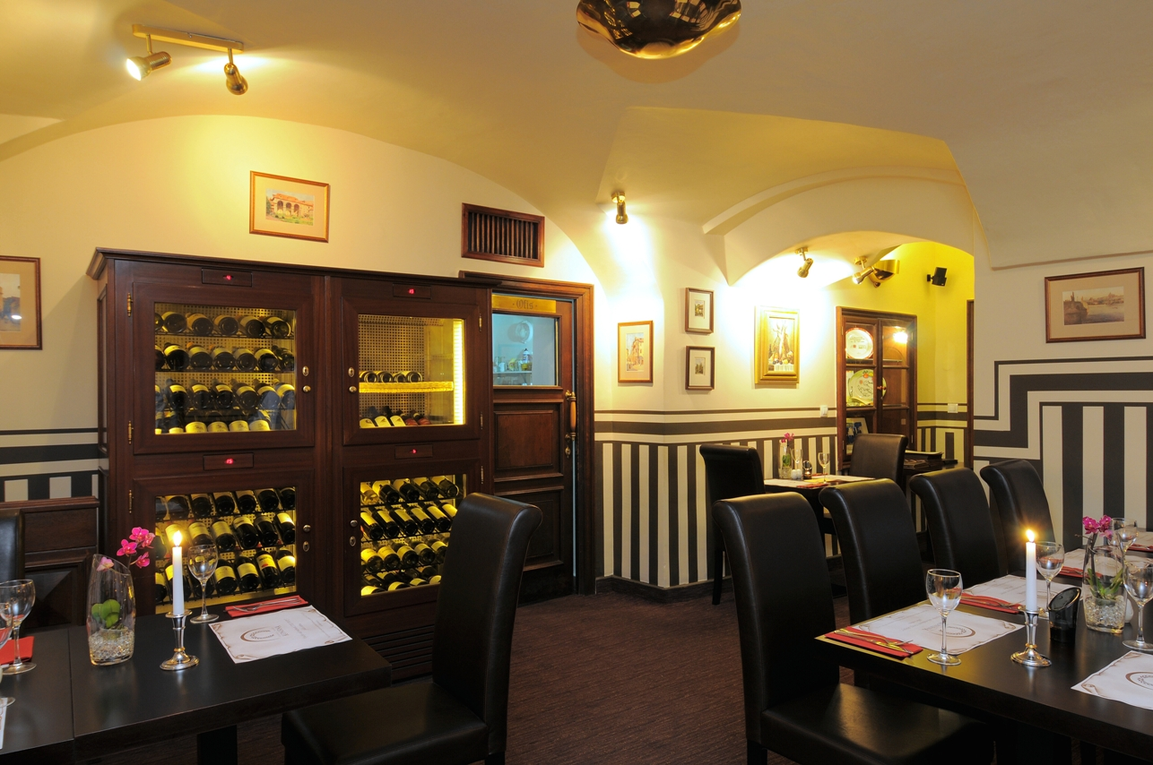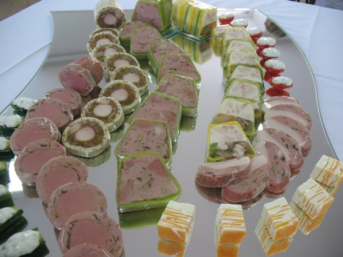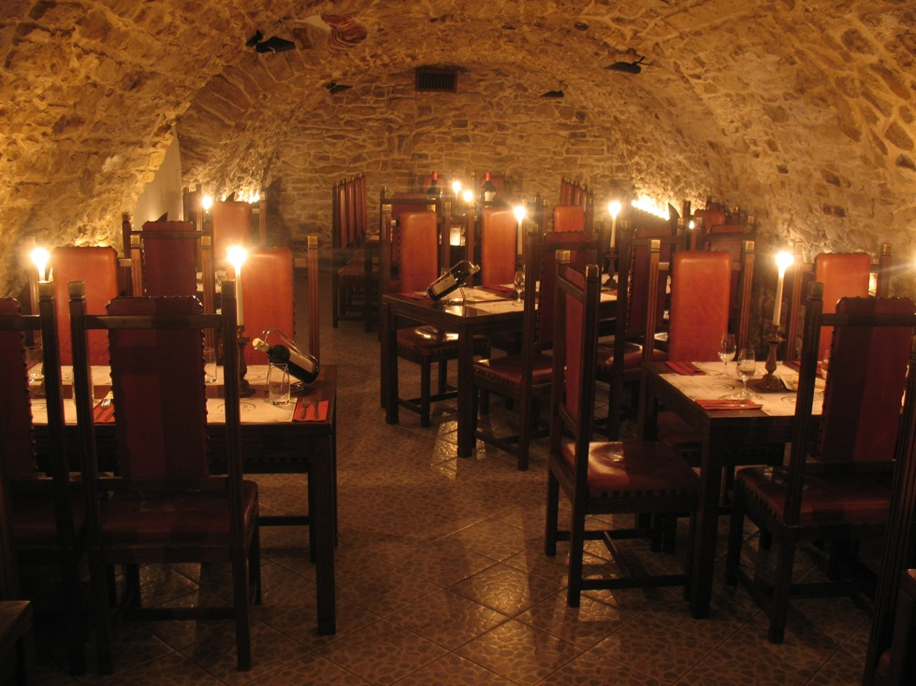

-3-

Modern buffet

Cold dishes
Prague ham with horseradish and pickled gherkins
Marinated salmon with onion sour cream
Insalata Caprese
Caesar salad
Greek salad with olives and feta cheese
Couscous salad with grilled vegetables and olive oil
Chicken pate, prosciutto and cantaloupe
Mini chicken schnitzels with lemon and pickled gherkins

Czech cheese platter (selection of soft and hard cheeses), served with grapes

Soup
Oxtail soup with noodles, vegetables and liver dumplings
or
Cream of potato soup with smoked salmon

Main dishes
Steamed Prague ham in wine, mashed potatoes with fried onions
Chicken sauté with mushrooms and cream, potato gnocchi with herbs
Grilled fish platter (salmon, carp, pike-perch) with noodles and vegetables

Desserts
Tiramisu roll, Sachertorte, fruit bowl
Fruit and chocolate mini-desserts

CZK 590

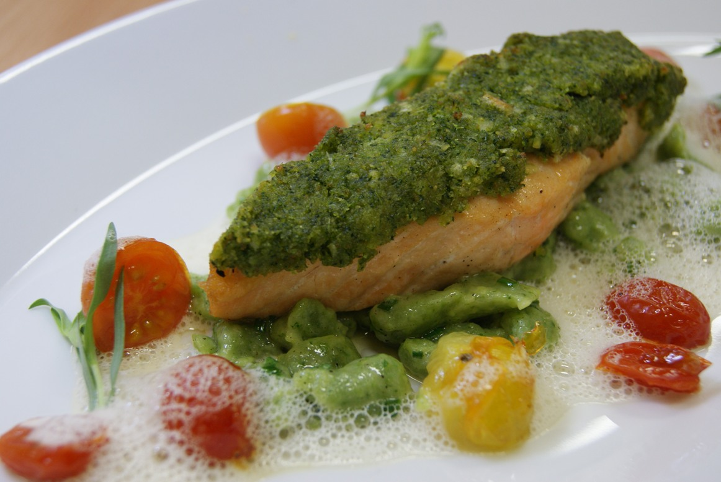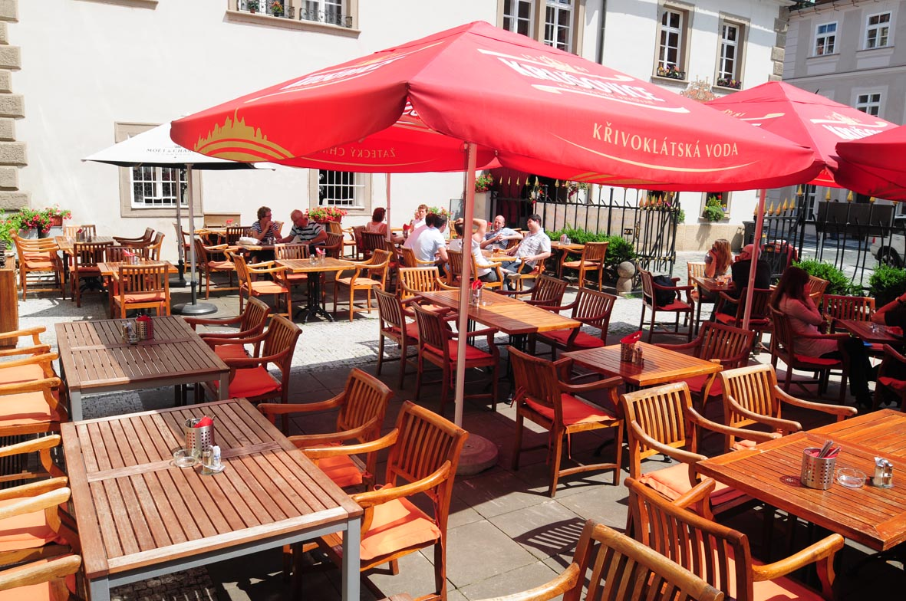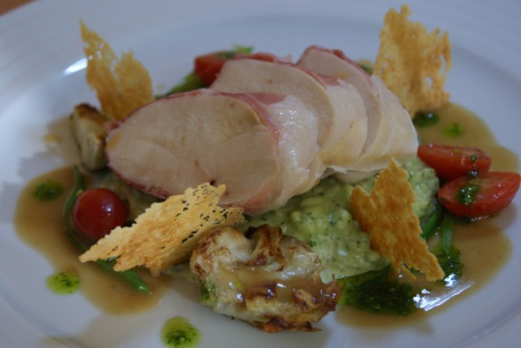

-4-

Beverages

 | Česká & moravská vína - Czech & moravian wines
0,75 | Ryzlink rýnský |  |  | 330,-
0,75 | Veltlínské zelené |  |  | 330,-
0,75 | Veltlínské zelené, vinařství Kosík, Tvrdonice |  |  | 430,-
0,75 | Veltlínské zelené, pozdní sběr, vinařství Kosík, Tvrdonice |  |  | 560,-
0,75 | Müller thurgau, vinařství Kosík, Tvrdonice |  |  | 430,-
0,75 | Müller thurgau, Velké Žernoseky, pan Kupsa |  |  | 450,-
0,75 | Müller thurgau, vinařství Baloun |  |  | 450,-
0,75 | Vlašský ryzlink, vinařství Baloun |  |  | 450,-
0,75 | Rýnský ryzlink, vinařství Baloun, pozdní sběr |  |  | 980,-
0,75 | Rýnský ryzlink, Dobrá vinice |  |  | 1 150,-
0,75 | Chardonnay, Dobrá vinice |  |  | 1 420,-
0,75 | Sauvignon blanc, Dobrá vinice |  |  | 1 550,-
0,75 | Vlašský ryzlink, vinařství Baloun, pozdní sběr |  |  | 680,-
0,75 | Chardonnay, pozdní sběr, vinařství Gala |  |  | 860,-
0,75 | Sauvignon, pozdní sběr, vinařství Gala |  |  | 920,-

 | Česká & moravská vína - Czech & moravian wines
0.75 | Svatovavřinecké |  |  | 330,-
0.75 | Frankovka |  |  | 330,-
0.75 | Frankovka, vinařství Baloun |  |  | 450,-
0.75 | Modrý Portugal, vinařství Baloun |  |  | 450,-
0.75 | Pinot Noir, pozdní sběr Rulandské modré |  |  | 990,-
0.75 | Merlot, vinařství Baloun |  |  | 990,-
0,75 | Merlot & Frankovka, pozdní sběr, vinařství Gala |  |  | 1 250,-
0,75 | Pinot Noir, pozdní sběr, vinařství Gala |  |  | 1 380,-
 | Nealko - Soft Drinks
0.20 | Coca-Cola, Coca-Cola light, Fanta, Sprite, Tonic, Soda |  |  | 39,-
0.20 | Juice pomeranč, multivitamin, jahoda, jablko, grep, hruška, |  |  | 45,-
0,20 | Černý rybíz, višeň, broskvo-malina |  |  | 45,-
0,33 | Mattoni |  |  | 45,-
0,33 | Perrier |  |  | 70,-
0,75 | Perrier |  |  | 120,-
0,75 | Eau de Perrier |  |  | 120,-
0.25 | Vittel |  |  | 70,-
1.00 | Vittel |  |  | 120,-
0.20 | Čerstvá pomerančová šťáva - Fresh Orange Juice |  |  | 65,-
0,33 | Kofola |  |  | 29,-
0,33 | Korunní perlivá |  |  | 26,-
0,33 | Aquila |  |  | 26,-
 | Džbán vody s citronem / Flagon of water with lemon |  |  | 60,-
 | Pivo - Beer
0.30 | Krušovice Mušketýr - světlé, tmavé, řezané | draught | beer | 21,-
0,50 | Krušovice Mušketýr - světlé, tmavé, řezané | draught | beer | 35,-
0.30 | Krušovický ležák 12°° - světlé, řezané lager beer | draught | beer | 27,-
0,50 | Krušovický ležák 12°° - světlé, řezané lager beer | draught | beer | 45,-
0,33 | Heineken, světlý ležák lager beer |  |  | 80,-
0,33 | Pilsner Urquell 12°° světlý ležák lager beer |  |  | 80,-
0,33 | Guinness |  |  | 80,-
 | Pivo nealkoholické - Beer non Alkoholic
0,33 | Fríí, nealkoholické - non Alkoholic |  |  | 39,-
0,33 | Birell, nealkoholické - non Alkoholic |  |  | 39,-
0,33 | Clausthaler, nealkoholické - non Alkoholic |  |  | 54,-
 | Káva - Coffee
9 g | Espresso |  |  | 49,-
 | Capucino, Laté, Macchiato |  |  | 70,-
 | Double espresso |  |  | 98,-
 | Horká čokoláda - Hot chocolate |  |  | 98,-
 | Vídeňská káva - Vienna Coffe |  |  | 98,-
 | Ledová káva - Ice coffee |  |  | 120,-
 | Alžírská káva - Algerian Coffe |  |  | 120,-
 | Irská káva - Irish Coffe |  |  | 120,-
 | mléko |  |  | 8,-
 | Čaj - Tea
 | Čaj - Tee Eilles všechny druhy z čajového lístku |  |  | 49,-
 | Svařené víno - Mulled wine |  |  | 49,-
 | Grog |  |  | 49,-

